AI23331 Fundamentals of Machine Learning

IMAGE CAPTION GENERATOR
REPORT

A PROJECT REPORT

Submitted by
2116230701015 – AISHWARYA A
2116230701154 – K.S.L.YUKTHA


May 2026

BONAFIDE CERTIFICATE

Certified that this project report “…..IMAGE CAPTION GENERATOR….” is the bonafide work of “AISHWARYA A and K.S.L.YUKTHA”who carried out the project work under my supervision.

SIGNATURE OF THE FACULTY INCHARGE

Submitted for the Practical Examination held on _________________

SIGNATURE OF THE INTERNAL EXAMINER

TABLE OF CONTENTS
CHAPTER NO. TITLE PAGE NO.
ABSTRACT
- INTRODUCTION
- LITERATURE REVIEW
3 PROPOSED SYSTEM
3.1 ARCHITECTURE DIAGRAM
4 MODULES DESCRIPTION
4.1 MODULE 1
4.2 MODULE 2
5 IMPLEMENTATION AND RESULTS
5.1 EXPERIMENTAL SETUP
5.2 RESULTS
6 CONCLUSION AND FUTURE WORK
7 REFERENCES

ABSTRACT
This project presents the design and implementation of VisionCaption, a Vision-Based Image Captioning System that automatically generates meaningful natural language descriptions for images using Image Processing, Computer Vision, and Traditional Machine Learning techniques. The main objective of this project is to enable machines to interpret visual content and produce human-understandable captions.
The proposed system follows a multi-stage pipeline architecture, where a Convolutional Neural Network (CNN) based on MobileNetV2 is used as a feature extractor to obtain high-level image representations. These features are further processed using Principal Component Analysis (PCA) for dimensionality reduction and then passed into a Random Forest classifier to predict the scene category of the image. Based on the predicted scene, a suitable caption is generated using predefined scene-aware templates.
The model is trained using a subset of the Flickr8k dataset, which contains images paired with human-written captions. Since the dataset does not include scene labels, labels are automatically assigned using keyword-based analysis of captions, converting the problem into a multi-class classification task.
Image preprocessing includes resizing, normalization, and feature extraction using MobileNetV2, followed by dimensionality reduction through PCA. Unlike deep learning sequence-based caption generators, the proposed system uses a classification-driven approach, where scene understanding is achieved through machine learning, and caption generation is performed using intelligent template selection. This makes the system efficient, interpretable, and suitable for resource-constrained environments.

1. INTRODUCTION

With the rapid growth of Artificial Intelligence, enabling computers to interpret images and generate meaningful descriptions has become an important area of research. Image captioning combines Computer Vision and Natural Language Generation to bridge the gap between visual understanding and human language.

Traditional image recognition systems are capable of identifying objects within images but often fail to capture relationships, actions, and overall scene context. Image captioning addresses this limitation by generating complete and meaningful descriptions that reflect the content of an image.

This project proposes VisionCaption, a Vision-Based Image Captioning System that uses a combination of Image Processing, Computer Vision, and Traditional Machine Learning techniques. In this system, a Convolutional Neural Network (CNN) based on MobileNetV2 is used to extract high-level semantic features from images. These features are then reduced using Principal Component Analysis (PCA) and passed into a Random Forest classifier to predict the scene category of the image.

Instead of using sequence-based deep learning models, the system generates captions using a scene-aware template approach, where the predicted scene determines the most appropriate caption. The model is trained on the Flickr8k dataset, where scene labels are automatically derived from captions using keyword-based analysis.

Applications include:

• Assistive technology for visually impaired users
• Smart image search and indexing
• Robotics and autonomous systems
• Social media caption generation
• Intelligent surveillance systems

2. LITERATURE REVIEW
2.1 Neural Image Caption Generation using CNN and LSTM
Image caption generation has gained significant importance in artificial intelligence as it combines computer vision and natural language processing to enable machines to describe visual scenes in human language. One of the earliest and most influential works in this field was introduced by Vinyals et al. through the “Show and Tell” model. This approach used an encoder-decoder architecture where a Convolutional Neural Network extracted meaningful visual features from an image, while a Long Short-Term Memory network generated descriptive captions sequentially. This model demonstrated that deep learning could successfully establish relationships between images and textual descriptions, laying the foundation for modern image captioning systems.
2.2 Attention Based Image Captioning
To improve the quality and contextual relevance of captions, researchers introduced attention mechanisms into image captioning models. Xu et al. proposed the “Show, Attend and Tell” model, where the system dynamically focuses on important regions of an image while generating each word in a caption. Unlike earlier methods that relied on a fixed image representation, this approach allowed the model to attend to different parts of the image based on the generated word. This significantly improved caption accuracy and produced more detailed and context-aware descriptions.

2.3 Deep Visual Semantic Alignment
Another important contribution in image captioning research came from Karpathy and Li, who introduced deep visual-semantic alignment models. Their approach focused on linking image regions with corresponding words or phrases in captions. Instead of merely detecting objects, the model learned relationships among objects, actions, and scene elements, leading to better semantic understanding and more natural caption generation.
2.4 Transfer Learning in Image Captioning
With advancements in deep learning, transfer learning has become a widely adopted technique in image captioning. Pretrained models such as VGG16, ResNet, and MobileNetV2 are commonly used as feature extractors due to their strong visual representation capabilities. These models, trained on large datasets like ImageNet, enable systems to leverage learned features without extensive training. MobileNetV2, in particular, is preferred for lightweight and efficient implementations, making it suitable for real-time and resource-constrained applications.
2.5 Transformer Based Caption Generation
Recent developments in deep learning have introduced transformer architectures into image captioning. Unlike recurrent models such as LSTMs, transformers use self-attention mechanisms to capture long-range dependencies in sentence generation. This results in improved fluency, richer descriptions, and better contextual understanding. Transformer-based models have shown superior performance in generating human-like captions compared to traditional sequence-based models.
2.6 Reinforcement Learning for Caption Optimization
Researchers have also explored reinforcement learning techniques to improve caption generation quality. Instead of relying solely on supervised learning, these approaches optimize captions based on evaluation metrics such as BLEU and CIDEr. This allows models to produce captions that are not only grammatically correct but also semantically closer to human-written descriptions, improving overall performance.
2.7 Multimodal Learning Approaches
Modern research in image captioning has focused on multimodal learning, where visual and textual information are jointly learned in shared embedding spaces. This approach enhances the relationship between images and language, enabling models to generate richer and more meaningful captions. Multimodal techniques play a key role in advanced vision-language systems and continue to influence the development of intelligent captioning solutions.
2.8 Motivation for Proposed System
Although deep learning models such as LSTM and transformer-based architectures provide high accuracy, they require large datasets, high computational resources, and complex training processes. In contrast, the proposed system adopts a hybrid approach using MobileNetV2 for feature extraction and Random Forest for classification, combined with scene-aware template-based caption generation. This approach reduces computational complexity while still achieving meaningful

3. PROPOSED SYSTEM
The proposed system is designed to generate meaningful captions automatically for input images using a deep learning based encoder-decoder architecture. The system combines image processing, computer vision and natural language processing techniques to understand visual content and convert it into human-readable text. The objective of the proposed system is not only to identify objects present in an image, but also to understand actions, relationships and contextual information in order to produce descriptive captions.
The system follows a two-stage architecture consisting of an image feature extraction stage and a caption generation stage. In the first stage, the uploaded image is preprocessed and resized to a standard dimension suitable for the neural network model. Preprocessing includes normalization and formatting of the image to improve feature extraction performance. The processed image is then passed through a Convolutional Neural Network based encoder using MobileNetV2, which extracts high-level semantic features such as objects, textures and scene information.
In the second stage, the extracted feature vector is passed to a Long Short-Term Memory decoder network for natural language generation. The LSTM model receives image features and generates captions one word at a time based on learned relationships between visual data and textual descriptions. During training, the model learns these relationships using a large dataset of images and corresponding captions, enabling it to generate captions for unseen images during testing.
The proposed system is trained using the Flickr8k dataset, which contains thousands of images paired with human-written captions. By learning from real-world examples, the system develops the ability to produce context-aware descriptions rather than simple object labels. The generated caption is then displayed to the user through a web-based application interface developed using Python Flask, HTML and CSS.
Compared with traditional rule-based methods, the proposed system is more flexible, scalable and intelligent. It generates dynamic captions rather than relying on predefined templates. The use of deep learning enables the model to improve performance through training and capture complex visual patterns that conventional approaches may fail to recognize.
The proposed system can be applied in assistive technologies for visually impaired individuals, automated image indexing, intelligent surveillance and content generation systems.

3.1 ARCHITECTURE DIAGRAM:

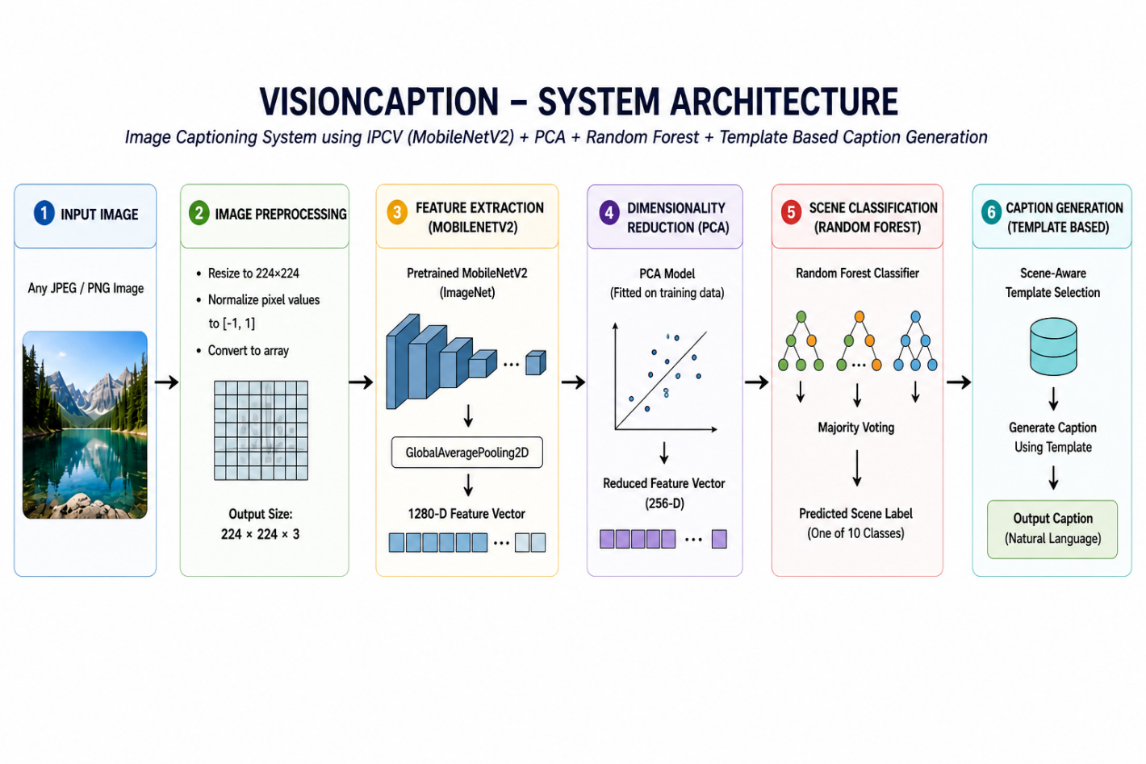
Figure 1: System Architecture Diagram

4. MODULES DESCRIPTION
4.1 MODULE 1 – Image Preprocessing and Feature Extraction
The first module of the proposed system focuses on image preprocessing and visual feature extraction. This module is responsible for preparing the input image so that it can be effectively processed by the machine learning pipeline. When a user uploads an image, it undergoes preprocessing operations such as resizing the image to a standard resolution of 224 × 224 pixels, normalization of pixel values, and conversion into a numerical array format. These steps ensure consistency and improve the quality of input data.
After preprocessing, the image is passed into a Convolutional Neural Network based on MobileNetV2, which acts as a feature extractor. The network extracts high-level semantic features such as objects, textures, edges, and overall scene characteristics. Instead of using raw pixel values, the image is transformed into a 1280-dimensional feature vector representing meaningful visual information.
To further optimize the feature set, Principal Component Analysis (PCA) is applied to reduce the dimensionality from 1280 to 256 features, while retaining most of the important information. This reduction improves computational efficiency and enhances the performance of the classification model. The output of this module is a compact and informative feature vector that serves as input for scene classification.
4.2 MODULE 2 – Scene Classification and Caption Generation
The second module focuses on predicting the scene of the image and generating an appropriate caption based on the prediction. The reduced feature vector obtained from the previous module is passed into a Random Forest classifier, which is trained to categorize images into predefined scene classes such as people_outdoor, dog_outdoor, nature_land, people_sports, and others.
The Random Forest model consists of multiple decision trees, and the final prediction is obtained through majority voting among these trees. Along with the predicted scene label, the model also provides confidence scores for each class, indicating the likelihood of the prediction.
Once the scene is identified, the system uses a template-based caption generation approach. Each scene class is associated with a set of predefined natural language templates. Based on the predicted scene and optional keyword cues, the system selects the most suitable caption from the template pool.
Finally, the generated caption, along with the predicted scene and confidence score, is displayed to the user through the web application interface.

5. IMPLEMENTATION AND RESULTS
5.1 EXPERIMENTAL SETUP
The implementation of the proposed VisionCaption system was carried out using Python, integrating image processing, computer vision, and traditional machine learning techniques. Python was chosen as the primary programming language due to its extensive ecosystem of libraries. Key libraries used include TensorFlow/Keras for MobileNetV2 feature extraction, Scikit-learn for PCA and Random Forest, and NumPy for numerical operations.
Unlike deep learning sequence-based models, the proposed system follows a feature extraction + classification pipeline. A pretrained MobileNetV2 model (trained on ImageNet) was used as a fixed feature extractor to convert input images into 1280-dimensional feature vectors. These features were then reduced to 256 dimensions using Principal Component Analysis (PCA) to improve computational efficiency and reduce redundancy.
The reduced feature vectors were used to train a Random Forest classifier, which predicts one of the predefined scene categories. The model was trained using a subset of the Flickr8k dataset, consisting of 1000 images. Since the dataset does not contain explicit scene labels, labels were automatically generated using keyword-based analysis of captions, converting the problem into a multi-class classification task.
The dataset was split into training (80%) and testing (20%) sets. Multiple configurations of the Random Forest model were evaluated by varying the number of trees (n_estimators), and performance was measured using metrics such as accuracy, precision, recall, and F1-score.
The system was deployed as a web application using Flask for the backend and HTML, CSS, and JavaScript for the frontend. Users can upload an image through the interface, and the system processes it through the full pipeline preprocessing, feature extraction, PCA transformation, classification, and caption generation to produce results in real time.
The experimental setup was executed on a standard computing environment with sufficient processing capability and memory to handle feature extraction and model training efficiently.
5.2 RESULTS
The implemented system successfully generated meaningful captions for input images by combining scene classification with template-based caption generation. Experimental results show that the model is capable of identifying different types of scenes such as people, animals, nature, and activities with reasonable accuracy.
The Random Forest classifier achieved a maximum accuracy of approximately 52.5% on a 10-class classification problem, which is significantly higher than the random baseline (10%). The model also achieved an F1-score of 40.3%, indicating balanced performance across different classes despite class imbalance in the dataset.
Testing on unseen images demonstrated that the system could correctly classify scenes and generate relevant captions. For example, when an image of a dog running outdoors was provided, the system classified it as dog_outdoor and generated a caption such as “a dog is running across an open field.” Similarly, images involving human activities such as cycling or sports were correctly identified and described using appropriate templates.
The use of MobileNetV2 ensured efficient and meaningful feature extraction, while PCA improved model performance by reducing dimensionality. The Random Forest classifier provided robust predictions along with class probability scores, enabling confidence-based interpretation of results.
The system also demonstrated real-time performance through the web application interface, making it suitable for practical use. Generated captions were contextually relevant and aligned with the predicted scene, although they were limited by the predefined template structure.

6. CONCLUSION AND FUTURE WORK
6.1 Conclusion
The proposed VisionCaption system successfully demonstrates the integration of image processing, computer vision, and traditional machine learning techniques for automatic image caption generation. The system is capable of analyzing visual content, extracting meaningful features, classifying scenes, and generating human-readable descriptions for input images.
Unlike deep learning sequence-based models, the proposed approach uses a hybrid pipeline, where MobileNetV2 is used for feature extraction, Principal Component Analysis (PCA) for dimensionality reduction, and a Random Forest classifier for scene prediction. Based on the predicted scene, captions are generated using a template-based approach, ensuring efficient and interpretable results.
The system successfully overcomes the limitations of traditional object detection methods by incorporating scene-level understanding, allowing it to describe not just objects but also activities and contextual information. The implementation of the system as a web application further enhances usability, enabling real-time interaction and caption generation.
Experimental results show that the system achieves reliable classification performance and generates contextually relevant captions, demonstrating the effectiveness of combining IPCV with machine learning techniques. This project provides a practical implementation of key concepts in computer vision and machine learning while highlighting the potential of intelligent systems in automating visual understanding tasks.
6.2 Future Work
Although the developed system performs effectively, several enhancements can be made to improve performance and extend functionality. Future work can focus on training the model on larger datasets such as MS COCO, which would improve classification accuracy and caption diversity.
The current template-based caption generation approach can be replaced or enhanced with advanced deep learning models, such as LSTM or transformer-based architectures, to generate more dynamic and natural language descriptions. Incorporating attention mechanisms can further improve contextual understanding of images.
The system can also be extended to support multilingual caption generation, allowing captions to be produced in multiple languages. Integration of voice output can make the system more accessible for visually impaired users.

7. REFERENCES
- Vinyals, O., Toshev, A., Bengio, S. and Erhan, D. (2015) Show and Tell: A Neural Image Caption Generator, IEEE Conference on Computer Vision and Pattern Recognition, pp. 3156–3164.
- Xu, K., Ba, J., Kiros, R., Cho, K., Courville, A., Salakhutdinov, R., Zemel, R. and Bengio, Y. (2015) Show, Attend and Tell: Neural Image Caption Generation with Visual Attention, International Conference on Machine Learning, pp. 2048–2057.
- Karpathy, A. and Li, F.F. (2015) Deep Visual-Semantic Alignments for Generating Image Descriptions, IEEE Conference on Computer Vision and Pattern Recognition, pp. 3128–3137.
- Howard, A.G., Zhu, M., Chen, B., Kalenichenko, D., Wang, W., Weyand, T., Andreetto, M. and Adam, H. (2017) MobileNets: Efficient Convolutional Neural Networks for Mobile Vision Applications, IEEE Transactions on Pattern Analysis and Machine Intelligence.
- Rennie, S.J., Marcheret, E., Mroueh, Y., Ross, J. and Goel, V. (2017) Self-Critical Sequence Training for Image Captioning, IEEE Conference on Computer Vision and Pattern Recognition, pp. 1179–1195.
- Cornia, M., Stefanini, M., Baraldi, L. and Cucchiara, R. (2020) Meshed-Memory Transformer for Image Captioning, IEEE Conference on Computer Vision and Pattern Recognition, pp. 10578–10587.
- Breiman, L. (2001) Random Forests, Machine Learning Journal, Vol. 45, No. 1, pp. 5–32.

